
LESSON NOTE | DETAILED EXPLANATORY NOTES
GENETICS & MOLECULAR BIOLOGY
PUNNETT SQUARES & MONOHYBRID CROSSES

GRADE 12 - BIOLOGY
■ ■ ■

Predicting Inheritance
Living things pass on features to their offspring through genes. A monohybrid cross follows the inheritance of a single characteristic - such as height in pea plants - controlled by one gene with two alleles. A Punnett square is a simple grid that lets us predict the genotypes and phenotypes of the offspring, and the ratios in which they appear. These tools, first developed from Gregor Mendel's experiments, are the foundation of genetics.
This lesson explains the key genetic terms, how to set up and read a Punnett square, how a monohybrid cross gives the classic 3:1 ratio, and how a test cross can reveal a hidden genotype. It is a core skill in the Genetics & Molecular Biology strand.
Why This Matters
- Punnett squares let us predict the results of a genetic cross.
- They explain Mendel's laws and the classic 3:1 ratio.
- They are used in plant and animal breeding and genetic counselling.
- They are the basis for understanding all inheritance patterns.
Punnett Squares & Monohybrid Crosses
Key Learning Outcomes
By the end of this lesson, students should be able to:
- Define gene, allele, genotype, phenotype, dominant and recessive.
- Distinguish homozygous and heterozygous genotypes.
- Set up and read a Punnett square for a monohybrid cross.
- Explain the P, F1 and F2 generations and the 3:1 ratio.
- Use a test cross to find an unknown genotype.
Key Genetic Terms
Genetics has its own vocabulary, and using it correctly is essential. A gene is a section of DNA that controls a characteristic; an allele is one version of that gene (for example, T for tall or t for short). The genotype is the combination of alleles an organism has (such as Tt), while the phenotype is the characteristic we can see (such as tall). If the two alleles are the same the organism is homozygous (TT or tt); if they are different, it is heterozygous (Tt). A dominant allele shows in the phenotype even when only one copy is present, while a recessive allele shows only when two copies are present.
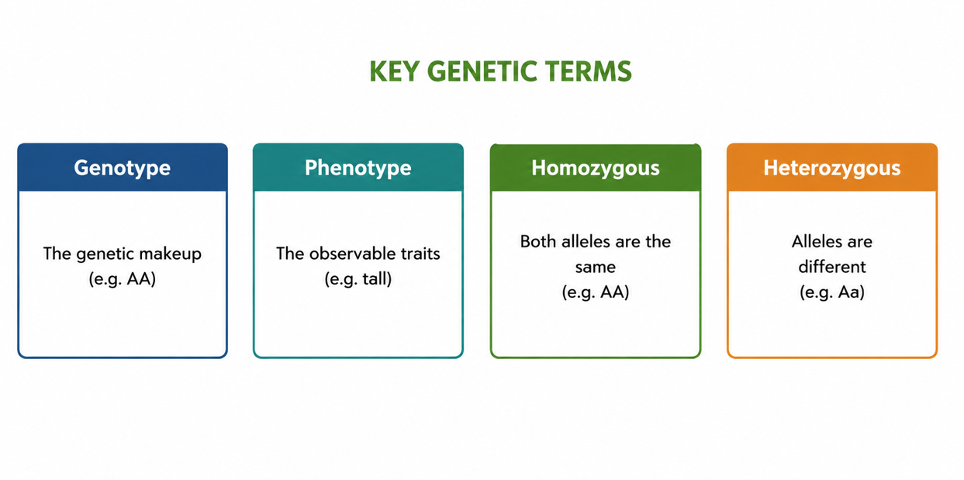
Figure 1: Key genetic terms - genotype vs phenotype, and homozygous vs heterozygous.
Terminologies and Concepts
Useful terms for this topic:
- Gene: a length of DNA that codes for a characteristic.
- Allele: one version of a gene (e.g. T or t).
- Dominant / recessive: an allele that shows with one copy / needs two copies.
- Genotype / phenotype: the alleles present / the appearance.
- Homozygous / heterozygous: two same alleles / two different alleles.
- Monohybrid cross: a cross following one characteristic.
- Punnett square: a grid used to predict offspring genotypes.
The Monohybrid Cross - P, F1 and F2
A monohybrid cross is followed over three generations. The parents (P) are usually pure-breeding (homozygous) - for example, a tall plant (TT) crossed with a short plant (tt). All their offspring, the first filial generation (F1), are heterozygous (Tt) and, because T is dominant, all appear tall. When two F1 plants are crossed, the second filial generation (F2) appears in a 3 tall: 1 short ratio. This 3:1 ratio is the hallmark of a monohybrid cross between two heterozygotes, and it comes directly from how alleles combine.
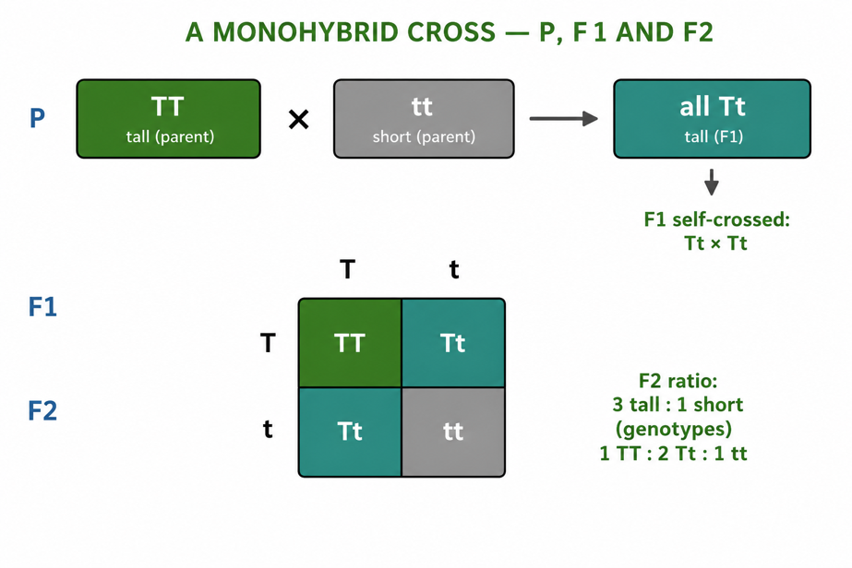
Figure 2: A monohybrid cross - pure-breeding parents give an all-tall F1, and the F2 shows a 3:1 ratio.
How to Build a Punnett Square
A Punnett square predicts the offspring of a cross in four simple steps. First, write the genotypes of both parents (e.g. Tt × Tt). Second, work out the possible gametes each parent can make - each gamete carries one allele (T or t). Third, write one parent's gametes across the top and the others down the side of a 2×2 grid. Fourth, fill in each box by combining the row and column alleles; the boxes show all the possible offspring genotypes and their proportions. For Tt × Tt, the result is 1 TT: 2 Tt: 1 tt genotypes, which gives a 3 tall: 1 short phenotype ratio.
The Test Cross
A tall plant could be either TT or Tt - we cannot tell just by looking, because both are tall. A test cross solves this by crossing the unknown tall plant with a homozygous recessive (short, tt) plant. If the tall plant is TT, all the offspring are tall. But if it is Tt, then about half the offspring are tall and half are short. The appearance of any short offspring reveals that the tall parent must be heterozygous (Tt). The test cross is a powerful tool used in breeding to identify hidden genotypes.
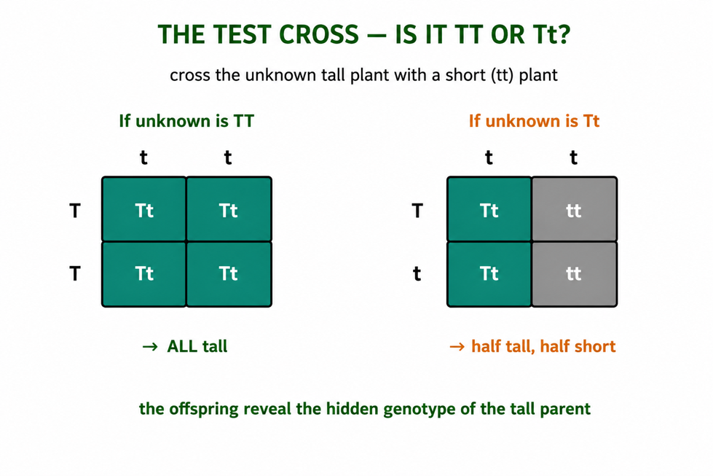
Figure 3: A test cross - crossing with a short (tt) plant reveals whether the tall parent is TT or Tt.
Worked Example - A Monohybrid Cross
Cross two heterozygous tall pea plants (Tt × Tt). The gametes are T and t from each parent. Filling in the Punnett square gives:
Tt × Tt → 1 TT: 2 Tt: 1 tt → 3 tall: 1 short
So, three-quarters of the offspring are expected to be tall and one-quarter short. These are probabilities, not guarantees - in a real cross the numbers will be close to, but not exactly, 3:1, and the more offspring there are, the closer the result gets to the predicted ratio.
Why This Matters
- Prediction - Punnett squares forecast the outcomes of crosses.
- Breeding - farmers use them to select for useful traits in crops and livestock.
- Health - they help predict the chance of inherited conditions in families.
- Foundation - they underpin all further genetics, including non-Mendelian patterns.
PNG Context Example
Monohybrid crosses and Punnett squares are directly useful in Papua New Guinea's farming. Breeders of kaukau (sweet potato), taro, coffee, cocoa and livestock use these ideas to select for traits like disease resistance, higher yield or better quality, crossing chosen parents and predicting the offspring. The same reasoning applies to human traits - predicting the chance that children inherit a condition - which supports basic genetic awareness in health care. Learning to build and read Punnett squares gives PNG students a practical tool for both agriculture and health.
References & Related Documents
Source Documents
- Biology Standards-Based Syllabus, Grades 11 & 12 (PNG SBC 2020) - Strand: Genetics & Molecular Biology; investigate Mendelian inheritance using monohybrid crosses and Punnett squares.
- STEM Biology Syllabus - Grade 12. Thema: Genetics; Module: Patterns of Inheritance. Department of Education, PNG.
Further Reading & References
- OpenStax Biology - Mendel's Experiments; Laws of Inheritance; The Punnett Square. https://openstax.org/books/biology
- Khan Academy - Introduction to heredity; Punnett squares. https://www.khanacademy.org/science/biology/classical-genetics

